|  |  |  |
| --- | --- | --- |
| **CL-1002 Programming Fundamentals** | **Scratch Booklet for reference** | |
| **NATIONAL UNIVERSITY OF COMPUTER AND EMERGING SCIENCES**  **Fall 202****2** | |  |
|  | |  |

**Introduction**

Visual Programming Language (VPL) is an application development environment designed on a graphical block-based programming model. Rather than a series of imperative commands sequentially executed. VPL is targeted for beginner programmers with a basic understanding of concepts such as variables and logics.

**Scratch** is a visual programming environment from MIT that allows you to learn computer programming while working on personally meaningful projects. It can be used to create interactive stories, games, animations, and images using script built with ready-to-use blocks. Scratch uses a single-window, multi-pane design to ensure that key components are always visible. Scratch programs, also called projects, are created by dragging, dropping, and snapping together different blocks.

**Scratch Interface**

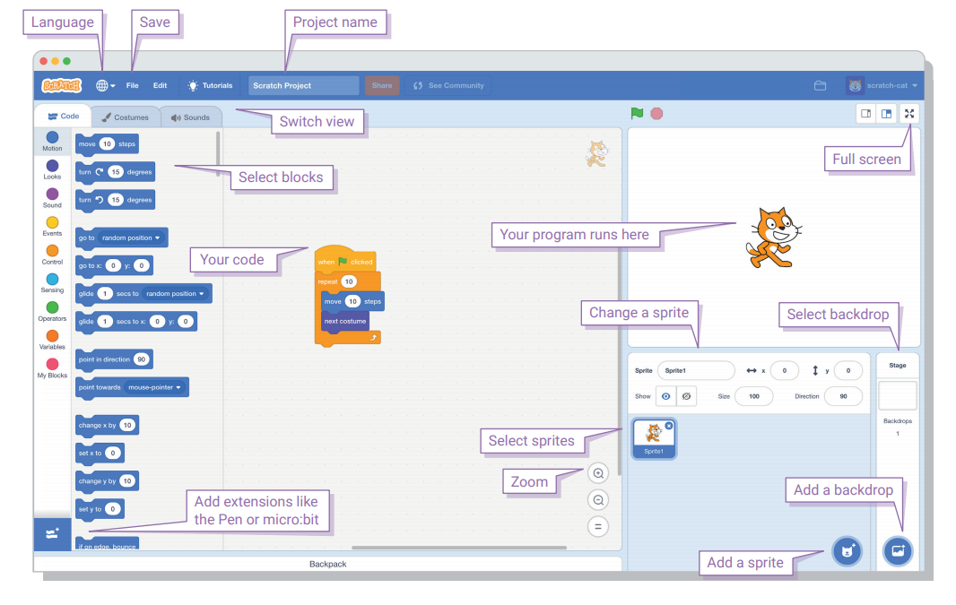

**Detail of Scratch programming Environment**

|  |  |
| --- | --- |
| Area | Function |
| Script | All blocks that are joined together are called a *script.* |
| Sprite | An object in **Scratch** which performs functions controlled by scripts. |
| Scripting Area | Where you will drag and drop the blocks that make up the script(s) your sprite(s) will follow. Each sprite that you create will have its own scripting area. |
| Block Palette | There are nine different Blocks category that are Motion, Looks, Sound, Pen, Data, Events, Control, Sensing, Operators and more Blocks |
| List of Blocks | Once you click on one of the categories listed, the different blocks that are included in this category are listed. |
| Resource Tab | There are three tabs:   * The Scripts tab is where you find all drag and drop blocks that make up the script(s). * The Costumes tab is where all of the poses or looks a sprite can have are created. When writing scripts for the staging area (referred to as the stage), this tab becomes the background tab. * The Sounds tab is where different sounds and pieces of the music a sprite can use are created. |
| Stage | This is the area where the sprites execute or run the script that you built in the scripting area. Clicking on the green flag allows you to start executing the script (if you set up your script to do so) and the red button will make the script stop. The Scratch stage is 480 steps wide and 360 steps tall |
| Sprite List | You can have as many sprites as you want in a single program. Clicking on an individual sprite shows you its scripting area. |
| Backdrop | A backdrop is one out of possibly many frames, or backgrounds, of the Stage. When you select backdrop the costume tab will become backdrop tab for editing. |

**Types of Blocks**

Scratch has four kinds of blocks: command blocks, function blocks, trigger blocks, and control blocks. Command blocks and control blocks (also called stack blocks) have bumps on the bottom and/or notches on the top. You can snap these blocks together into stacks. Trigger blocks, also called hats, have rounded tops because they are placed at the top of a stack. Trigger blocks connect events to scripts. They wait for an event—such as a key press or mouse click—and run the blocks underneath them when that event happens. For example, all scripts that start with the when green flag clicked block will run when the user clicks the green flag icon.

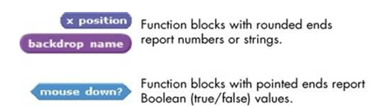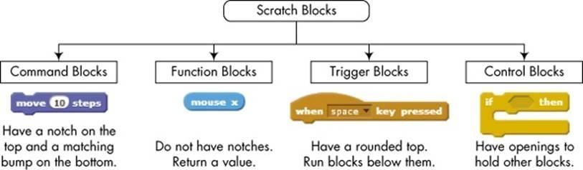

**Block Palette Description**

The Scratch blocks are organized into nine color-coded categories: Motion, Looks, Sound, Event, Control, Sensing, Operators, Variables and More Blocks.

## Motion

The category **Motion** groups’ sprite movement blocks, used for their movement, rotation and reading current data related to a sprite’s location. These are very often used basic blocks. Below is a description of all the blocks in this category.

|  |  |
| --- | --- |
| Motion | |
|  | Moves sprite forward or backward. |
|  | Rotates sprite clockwise. |
|  | Rotates sprite counterclockwise. |
|  | Points sprite in the specified direction. (0=up, 90=right, 180=down, -90=left) |
|  | Points sprite toward mouse-pointer or another sprite. |
|  | Moves sprite to specified x and y position on Stage. |
|  | Moves sprite to the location of the mouse-pointer or another sprite. |
|  | Moves sprite smoothly to a specified position over specified length of time. |
|  | Changes sprite’s x-position by specified amount. |
|  | Sets sprite’s x-position to specified value. |
|  | Changes sprite’s y-position by specified amount. |
|  | Sets sprite’s y-position to specified value. |
|  | Turns sprite in opposite direction when sprite touches edge of Stage. |
|  | Reports sprite’s x-position. (Ranges from -240 to 240) |
|  | Reports sprite’s y-position. (Ranges from -180 to 180) |
|  | Reports sprite’s direction. (0=up, 90=right, 180=down, -90=left) |

## Looks

The **Looks** category is a collection of sprite appearance blocks concerning costume, size, visibility, etc. Some of these blocks are used very often. Below is a description of most blocks in this category.

|  |  |
| --- | --- |
| Looks | |
|  | Changes sprite’s appearance by switching to different costume. |
|  | Changes sprite’s costume to next costume in the cos- tume list. (If at end of the costume list, jumps back to first costume.) |
|  | Reports sprite’s current costume number. |
|  | Changes Stage’s appearance by switching to a different background or backdrop |
|  | Changes Stage’s background to next backdrop in the backdrop list. |
|  | Reports Stage’s current background or backdrop number. |
|  | Displays sprite’s speech bubble for specified amount of time. |
|  | Displays sprite’s speech bubble. (you can remove speech bubble by running this block without any text.) |
|  | Displays sprite’s thought bubble for specified amount of time. |
|  | Displays sprite’s thought bubble. |
|  | Changes a visual effect on a sprite by specified amount.  (Use pull-down menu to choose effect.) |
|  | Sets a visual effect to a given number. (most visual effects range from 0 to 100.) |
|  | Clears all graphic effects for a sprite. |
|  | Changes sprite’s size by specified amount. |
|  | Sets sprite’s size to specified % of original size. |
|  | Reports sprite’s size, as % of original size. |
|  | Makes sprite appear on the Stage. |
|  | Makes sprite disappear from the Stage. (When sprite is hidden, other sprites cannot detect it with **touching?** block.) |
|  | Moves sprite in front of all other sprites. |
|  | Moves sprite back a specified number of layers, so that it can be hidden behind other sprites. |

## Sound

The **Sound** category is a group of blocks for sounds, instruments and musical notes.

|  |  |
| --- | --- |
|  | Sets the type of instrument that the sprite uses for  **play note** blocks. (Each sprite has its own instrument.) |
|  | Changes sprite’s sound volume by specified amount.  Volume ranges from 0 to 100. |
|  | Sets sprite’s sound volume to specified value. |
|  | Reports sprite’s sound volume. |
|  | Changes sprite’s tempo by specified amount. |
|  | Sets sprite’s tempo to specified value in beats per minute. |
|  | Reports sprite’s tempo in beats per minute. |



## Control

The **Control** category contains very important blocks – equivalent to instructions controlling programming languages (loops, conditional instructions). Below is a description of all the blocks in this category.

|  |  |
| --- | --- |
| Control | |
|  | Runs script below when green flag is clicked. |
|  | Runs script below when specified key is pressed. |
|  | Runs script below when sprite is clicked. |
|  | Waits specified number of seconds, then continues with next block. |
|  | Runs the blocks inside over and over. |
|  | Runs the blocks inside a specified number of times. |
|  | Sends a message to all sprites, then continues with the next block without waiting for the triggered scripts. |
|  | Sends a message to all sprites, triggering them to do something, and waits until they all finish before continuing with next block. |
|  | Runs script below when it receives specified broadcast message. |
|  | Continually checks whether condition is true; whenever it is, runs the blocks inside. |
|  | If condition is true, runs the blocks inside. |

|  |  |
| --- | --- |
|  | If condition is true, runs the blocks inside the **if** portion; if not, runs the blocks inside the **else** portion. |
|  | Waits until condition is true, then runs the blocks below. |
|  | Checks to see if condition is false; if so, runs blocks inside and checks condition again. If condition is true, goes on to the blocks that follow. |
|  | Stops all scripts in all sprite, current sprite or other sprite. |
|  | Tells a clone what to do once it is created |
|  | Creates a clone (temporary duplicate) of the specified sprite |
|  | Deletes the current clone |



## Sensing

The **Sensing** category includes blocks related to the recognition of different situations that occur on the stage concerning, among others, sprites and the mouse, blocks to pull data from the keyboard, and blocks associated with the timer, date and camera. Below is a description of most blocks in this category, except for the camera operation and date blocks.

Sensing

|  |  |
| --- | --- |
|  | Reports true if sprite is touching specified sprite, edge, or mouse-pointer. (Select from pull-down menu.) |
|  | Reports true if sprite is touching specified color. (Click on color patch, then use eyedropper to select color.) |

|  |  |
| --- | --- |
|  | Asks a question on the screen and stores keyboard input in the . Causes the program to wait until the Enter key is pressed or check mark is clicked. |
|  | Reports keyboard input from the most recent use of  . Shared by all sprites (global). |
|  | Reports the x-position of mouse-pointer. |
|  | Reports the y-position of mouse-pointer. |
|  | Reports true if mouse button is pressed. |
|  | Reports true if specified key is pressed. |
|  | Reports distance from the specified sprite or mouse-pointer. |
|  | Sets the timer to zero. |
|  | Reports the value of the timer in seconds. (The timer is always running.) |
|  | Reports a property or variable of another sprite. |
|  | Reports the volume (from 1 to 100) of sounds detected by the computer microphone. |
|  | Senses how much **motion** or **direction** is currently in the video image |
|  | Turns the video camera on |
|  | Sets the video transparency |
|  | Reports the current time |
|  | Reports the number of days since 2000 |
|  | Reports username of the viewer |



## Operators

The category of **Operators** groups blocks of basic arithmetic operations, logical operations and various functions (both arithmetic and on texts). All blocks in this category are used as arguments for other blocks. Below is a description of most blocks in this category.

|  |  |
| --- | --- |
| Operators | |
|  | Adds two numbers. |
|  | Subtracts second number from first number. |
|  | Multiplies two numbers. |
|  | Divides first number by second number. |
|  | Picks a random integer within the specified range. |
|  | Reports true if first value is less than second. |
|  | Reports true if two values are equal. |
|  | Reports true if first value is greater than second. |
|  | Reports true if both conditions are true. |
|  | Reports true if either condition is true. |
|  | Reports true if condition is false; reports false if condition is true. |
|  | Concatenates (combines) strings. |
|  | Reports the number of letters in a string. |
|  | Reports the letter at the specified position in a string. |
|  | Reports result of selected function (abs, sqrt, sin, cos, tan, asin, acos, atan, ln, log, e^, 10^) applied to specified number. |
|  | Reports remainder from division of first number by second number. |
|  | Reports closest integer to a number. |



## Variable

The **variable** category contains buttons for creating variables. Once we have created our own variables, blocks will appear to be modified and use values. Variables allow us to store data. We can delete a variable.



## Events

The **Events** category includes blocks which start scripts reacting to specific events (e.g. clicking a sprite with the mouse, pressing a key on the keyboard) and related to message support (self-generating events in the program). Below is a description of almost all the blocks in this category.

|  |  |
| --- | --- |
| Event | |
|  | The basic block. It starts the majority of scripts. Scripts are run when we click the green flag on the screen – start the programme. |
|  | Runs the script after pressing a specific key on the keyboard. We select a key from a drop-down list. |
|  | The block runs the script when we left-click the sprite. |
|  | The block runs the script when a change of background occurs. The background name can be selected from a drop-down list. The script will be started when the background becomes the current  one (displayed on the stage) |
|  | Runs a script when the selected attribute (loudness, timer, video motion) is greater than a specified value |
|  | The block starts the script when a message of the specified name  selected from the drop-down list is broadcast. |
|  | This block allows us to define and broadcast a message. We can choose the message name from the drop-down list or define a new message using the **new message...** option available when we  expand the list. |
|  | Works in the same way as the block **broadcast *message name*** . The difference is that the operation of the script in which the message was broadcast is paused until the end of the operation of  all the scripts receiving this message. |
| More Blocks  More blocks allow user to build user define procedures or functions. | |
| More Blocks | |
|  | Creates a custom block A **define** block will appear in Scripts. Use **define** to tell the custom block what to do |
|  | Add blocks that extend what you can do in Scratch Like LEGO and WeDo |

## Pen

The **Pen** category is a collection of blocks connected with a sprite’s pen, its status, colour and thickness. This group also includes a block used to clear created drawings and the possibility of copying the sprite’s image as a stamp. Below is a description of all the blocks in this category.

|  |  |
| --- | --- |
| Pen | |
|  | Clears all pen marks and stamps from the Stage. |
|  | Puts down sprite’s pen, so it will draw as it moves. |
|  | Pulls up sprite’s pen, so it won’t draw as it moves. |
|  | Sets pen’s color, based on choice from color picker.  Picking the color also changes the pen shade. |
|  | Changes pen’s color by specified amount. |
|  | Sets pen’s color to specified value. (pen_color=0 at red end of rainbow, pen_color=100 at blue end of rainbow. Ranges from 0 to 200 to go around the color wheel.) |
|  | Changes pen’s shade by specified amount. |
|  | Sets pen’s shade to specified amount. (pen_shade=0 is very dark, pen_shade=100 is very light. Default is 50, unless set with color picker.) |
|  | Changes pen’s thickness. |
|  | Sets pen’s thickness. |
|  | Stamps sprite’s image onto the Stage. |

## Sprite costumes

When we select the tab costume, we can change sprite costumes, i.e. sprite pictures. The tray contains all of the sprite’s costumes. The panel on the right side is now a graphics editor where we can create or change a costume.

**Sounds**

After we select the Sounds tab we can change and add sounds for a sprite. We have the option to add new sounds and process them.

**Backdrop:**

When clicking to backdrop a window is open which allows users to create backdrops with the bitmap tools and techniques in Bitmap Mode. The Bitmap Paint Editor is the default editor when creating a backdrop. By clicking the Convert to Vector button, users can backdrops with the vector editing tools and techniques in Vector Mode.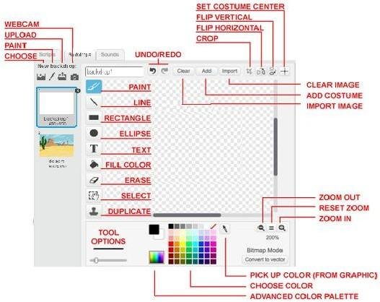

## CREATING YOUR FIRST SCRIPT IN SCRATCH:

We're going to create a script for the cat sprite to make it move and say Hello. The script start with an event, First you have to select the “Events’ block and drag the block “with the space key pressed” to the right and drop it by releasing the mouse button.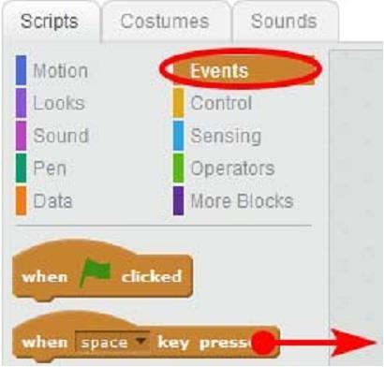

Now Select the Blue Motion Block and drag the “move 10 step” to the right. Fix it under the brown block. Release the mouse button and it will be attached.

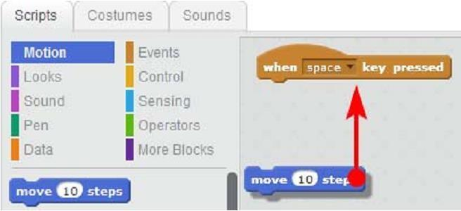

Now select “looks” and drag the block “say Hello” to the right and attached with the blue one.

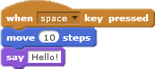

Now your script is ready to be execute press the spacebar and see how the cat is moving and saying Hello. If you keep on pressing, he will go to the edge of the screen and will hide there.



You can expand the script by removing “say Hello” block and replacing it with blue block named “if on edge bounce” .Now cat moves silently to the screen edge , pushes off, turn back and stands on his head.

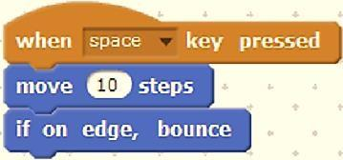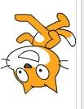

### Tracing Path of Sprite to make Colorful Flower:

We can trace the path of a sprite by using the pen to draw on the stage.it can be used to draw many different things. In this example you will learn to draw flower by using only pen, loops and color.

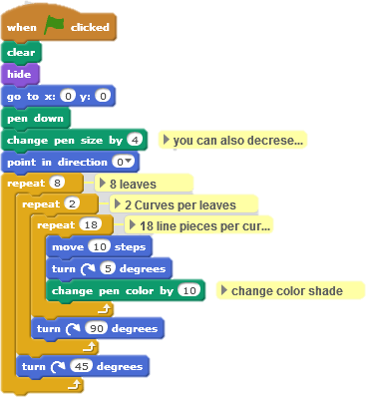

### Performing arithmetic operations using variables

In this example you learn to utilize variables, control blocks and function blocks. For arithmetic operation we first need to define 2 variables work as operand. The sprite then ask user to enter numbers for division operation. Numbers are initially stored in answer block and then assigned to appropriate variable. The conditional block checks for condition if the divisor is non zero then it perform the operation over 2 operands otherwise it says “Try again”.

Similarly we can perform addition, subtraction or any other mathematical operation. Variables can also be used to store strings.

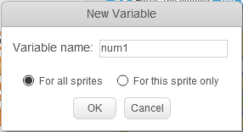

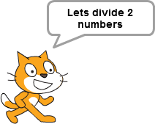

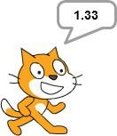

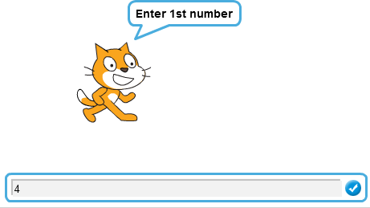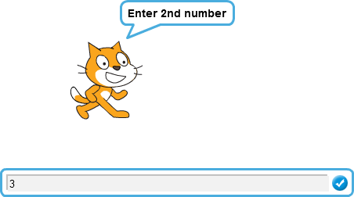

### Fundamental concepts Support by Scratch:

While creating project with scratch, it offers a wide number of fundamental Programing and computational concept.

|  |  |  |
| --- | --- | --- |
| **Concept** | **Explanation** | **Example** |
| **Sequence** | Creating just about any program in Scratch requires thinking of the order of steps |  |
| **Iteration (looping)** | **forever** and **repeat** are examples of iteration. |  |
| **Conditional statements** | **if, if-else** and **waituntil** check for a condition |  |
| **Procedures** | The *Make a Block* feature lets you define a new block that you use in your scripts.  Defining a block can also be called naming a procedure. The Make a Block feature allows reusing code within a sprite, and can support modularity and abstraction. |  |
| **Threads (parallel execution)** | Launching two stacks at the same time creates two independent threads that execute in parallel. |  |

|  |  |  |
| --- | --- | --- |
| **Synchronization** | **broadcast** can coordinate the actions of multiple sprites | For example, Sprite1 sends message when condition is met:    This script in Sprite2 is triggered when the message is received: |
| **Real-time interaction** | **mouse_x**, **mouse_y,** and **loudness** can also be used as dynamic input for real-time  interaction. |  |
| **Time triggering** | Scratch includes an internal clock that you can access with **timer** |  |
| **Boolean logic** | **and**, **or**, or **not** are examples of boolean logic |  |
| **Variables** | The Variables category allows creating a new  variable and using it in a program  Scratch supports both global and object-specific variables. |  |
| **Random numbers** | The **pick random** block selects random integers within a given range |  |
| **Event handling** | **when key pressed** and **when sprite1 clicked** are examples of event handling— responding to events triggered by the user or another part of  the program |  |

|  |  |  |
| --- | --- | --- |
| **Object-oriented programming** | Each sprite can have its own scripts and data. (However, Scratch has no classes and no Inheritance.) |  |
| **User interface design** | You can design interactive user interfaces in Scratch – for example, using clickable sprites to create buttons. |  |
| **List ( array)** | The list blocks allow for storing and accessing a list of numbers and strings. This kind of data structure can be considered a “dynamic array.” |  |
| **Cloning** | *create clone* makes a copy of a sprite that exists until the project stops running. You can use it to dynamically create many copies of the same sprite with the same code. |  |
| **Physical sensing** | Blocks such as loudness allow interactions with microphones and other physical interfaces. |  |

